ASCENDING ORDER

# EXP NO: 10

## AIM:

To compute ascending order of an array using 8085 processor.

ALGORITHM:  
 1.  Initialize HL pair as memory pointer.  
 2.  Get the count at memory and load it into C register  
 3.  Copy it in D register (for bubble sort (N-1)) times required).  
 4.  Get the first value in A register.  
 5.  Compare it with the value at next location.  
 6.  If they are out of order, exchange the contents of A register and memory.  
 7. Decrement D register content by 1  
 8. Repeat step 5 and 7 till the value in D register become zero.  
 9. Decrement the C register content by 1.  
 10. Repeat steps 3 to 9 till the value in C register becomes zero.

PROGRAM:  
 LOOP: LXI H,3500  
 MVI D,00  
 MVI C,05  
 LOOP1: MOV A,M  
 INX H  
 CMP M  
 JC LOOP2  
 MOV B,M  
 MOV M,A  
 DCX H  
 MOV M,B  
 INX H  
 MVI D,01  
 LOOP2: DCR C  
 JNZ LOOP1  
 MOV A,D  
 RRC  
 JC LOOP  
 HLT

INPUT:

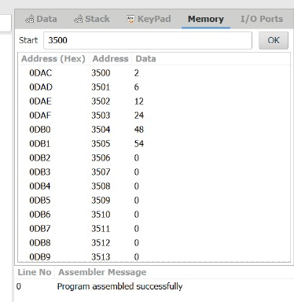

## OUTPUT:

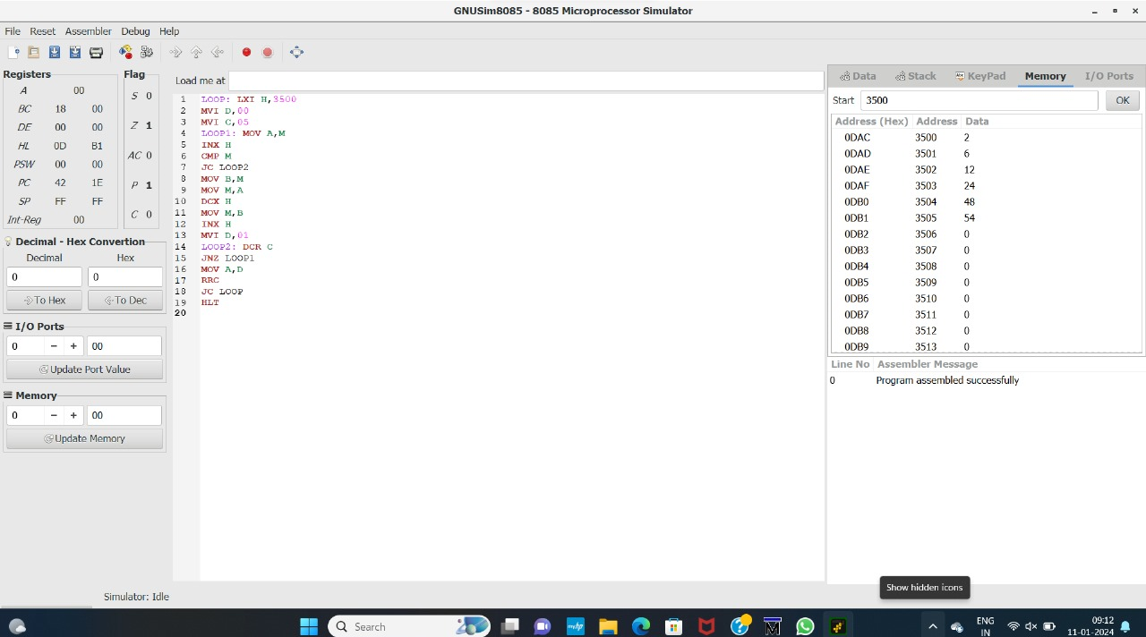

## RESULT:

Thus the program was executed successfully using 8085 Processor Stimulator.